**Practical No 5**

* **Set PIG_HOME in environment variable**

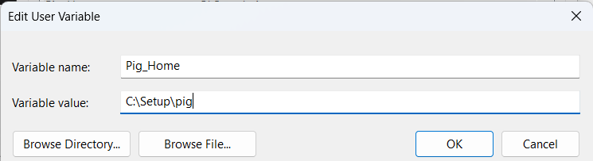

* **Add path**

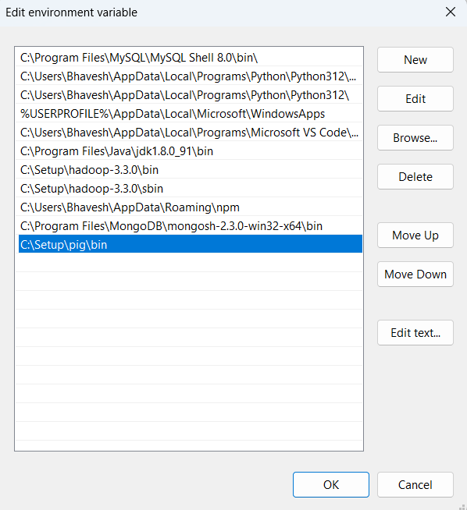

* **Find the line in pig.cmd in \bin folder :**

set HADOOP_BIN_PATH=%HADOOP_HOME%\bin

Replace this line by:

set HADOOP_BIN_PATH=%HADOOP_HOME%\libexec

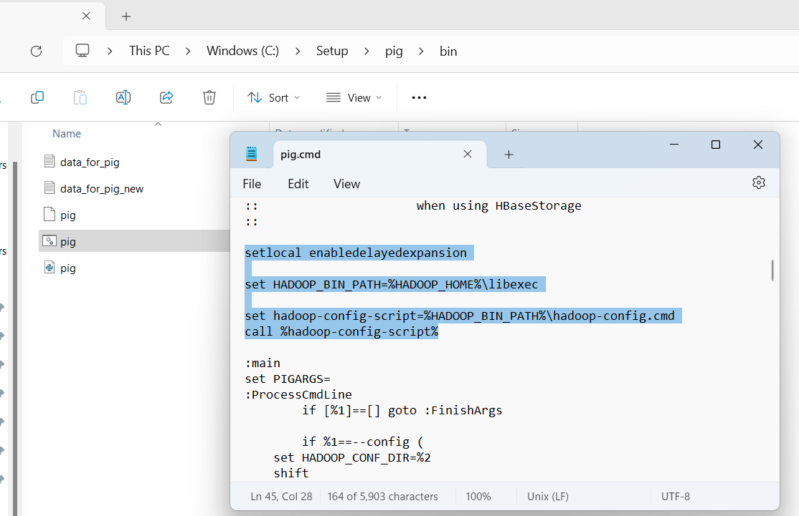

* **Starting All Services and Check pig command on cmd**

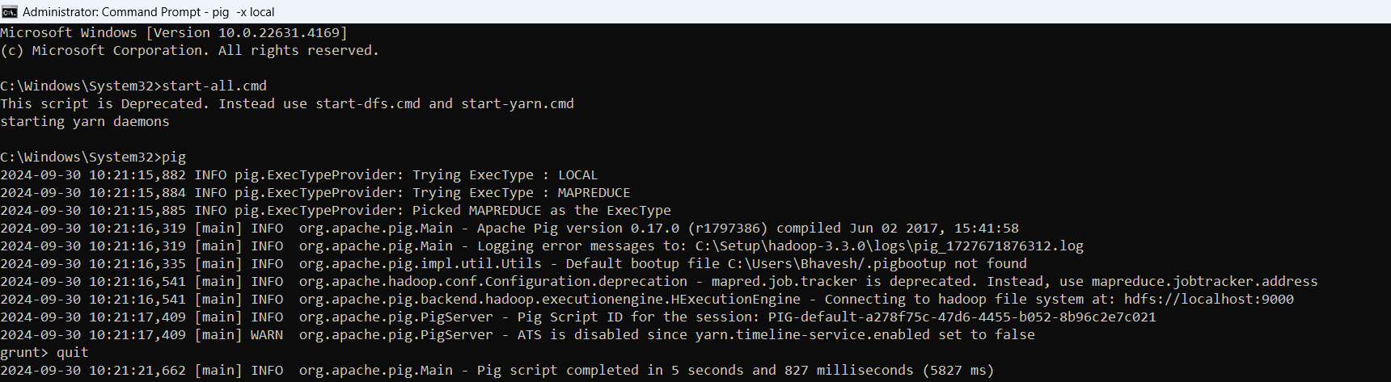

* **Create a file data_for_pig.txt with following data:**

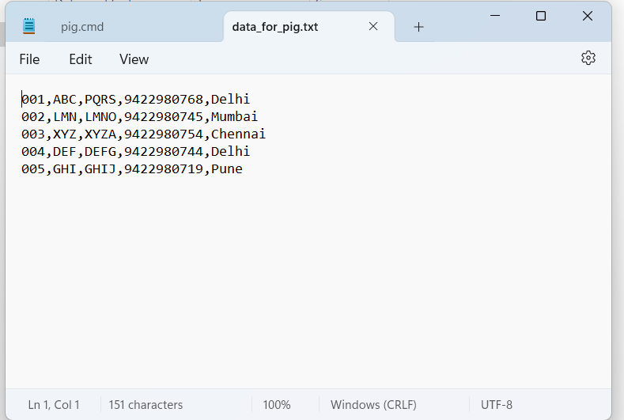

* **Create a file data_for_pig_new.txt with following data:**

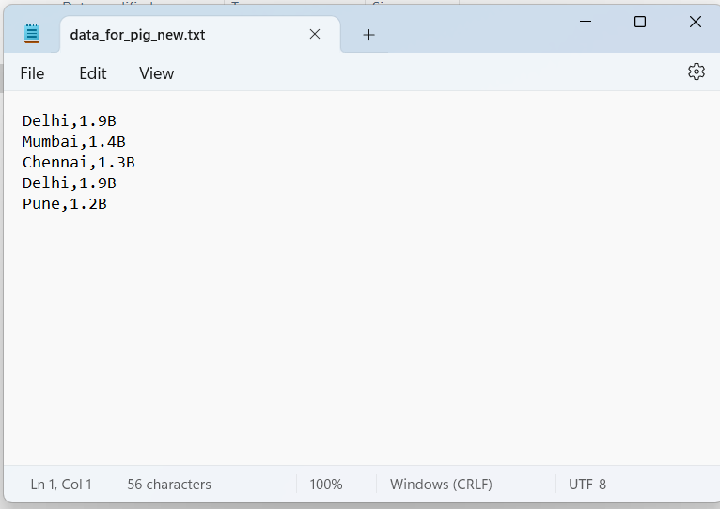

* **Check Directory on Web browser**

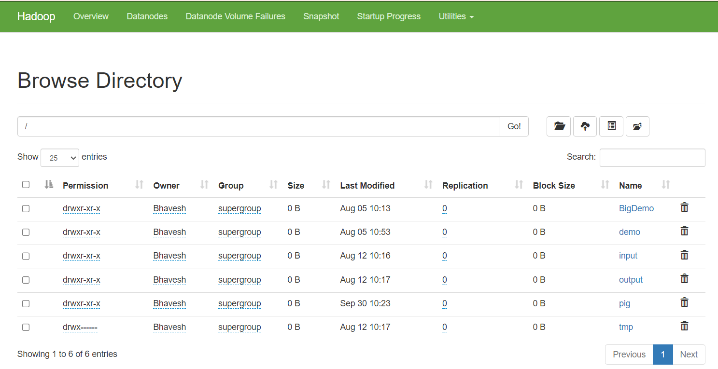

* **Create Pig folder -hdfs dfs -mkdir /pig**
* **Upload data_for_pig.txt file on HDFS**
* **Upload data_for_pig_new.txt file on HDFS**

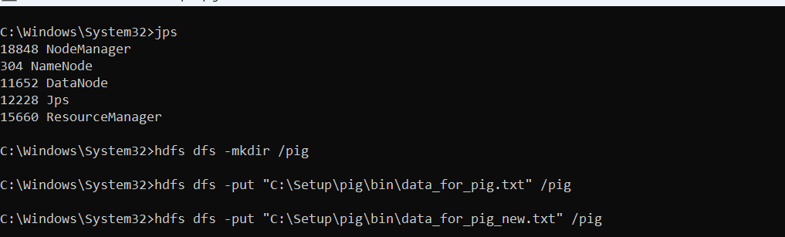

* **Copy data_for_pig.txt and data_for_pig_new.txt in the Pig folder**
* **cat data of file**

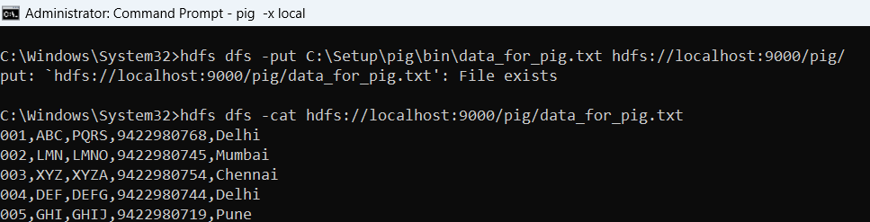

* **Run other database related commands**
* **Invoking the grunt shell:-pig -x local**
* **Create variable student**

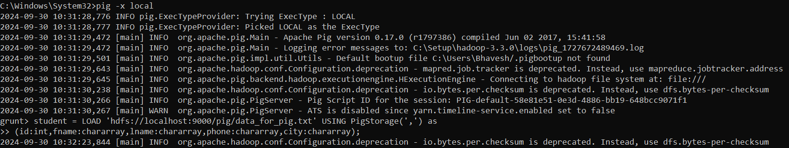

* **Display the student data on the command prompt using command- dump student;**

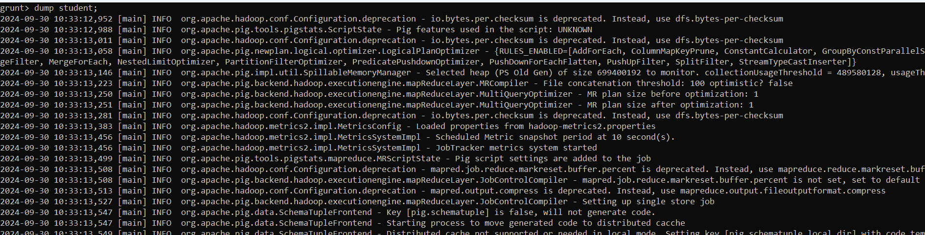

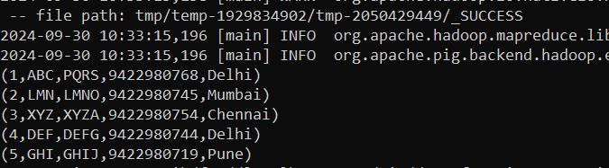

* **Create variable city and display city data**



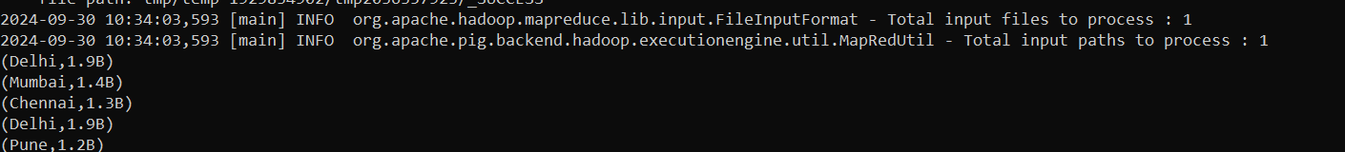

* **Create variable for_each_stud1 and display for_each_stud1 data**



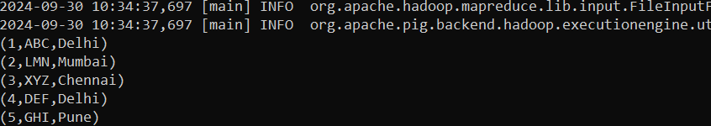

* **Create variable filter_command and display filter_command data**

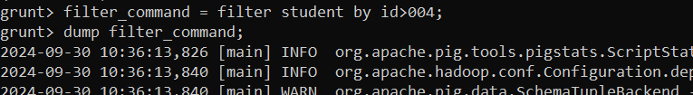



* **Create variable join_command and display join_command data**



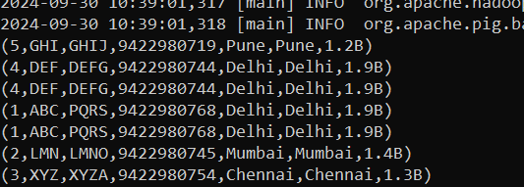

* **Create variable order_command_asc and display order_command_asc data**

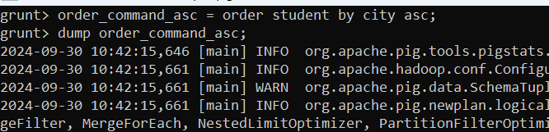

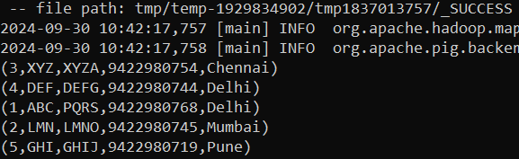

* **Create variable order_command_desc and display order_command_desc data**

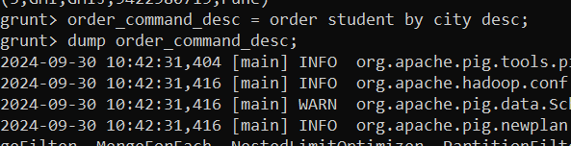

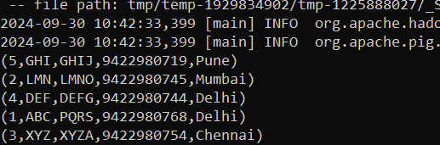

* **Create variable distinct_command and display distinct_command data**

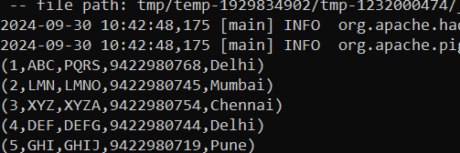

* **Store Order_command_desc**



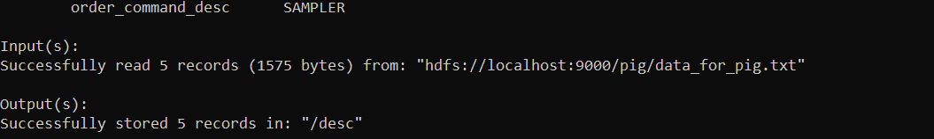

* **Group command (Duplication is city is required)**
* **Create variable group_command and display group_command data**

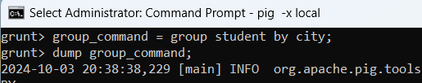

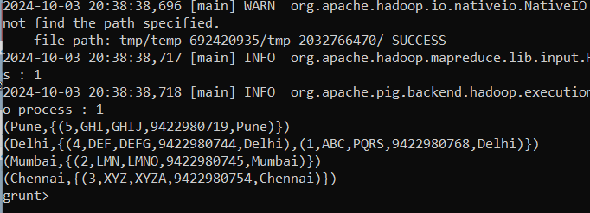

* **Create variable co_group_command and display co_group_command data**

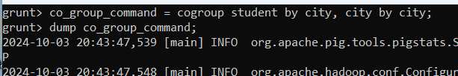

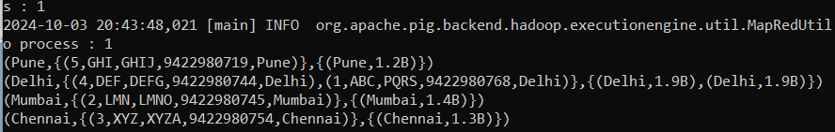

* **Create variable cross_command and display cross_command data**

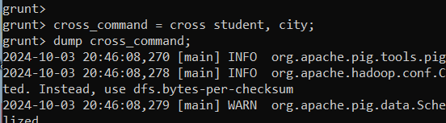

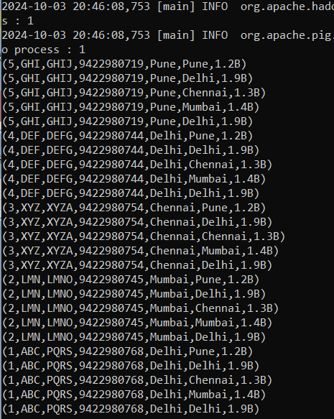

* **Create variable limit_command and display limit_command data**

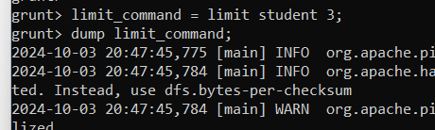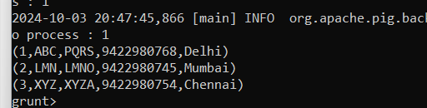

* **Split the Student variable into x and y**

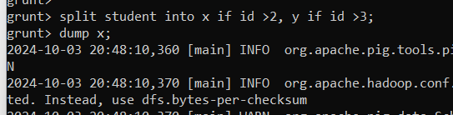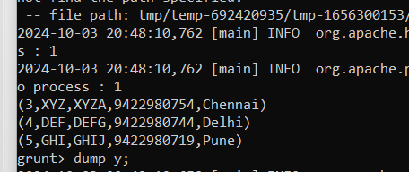

* **Display y variable of student**

